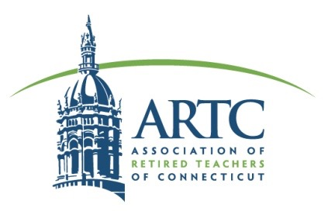
Feb. 21, 2024

Dear Legislator,

On behalf of retired teachers, The Association of Retired Teachers of Connecticut (ARTC) is seeking your support for Proposed Bill No. HB 5010 AN ACT CONCERNING A STATE SUBSIDY FOR RETIRED TEACHERS’ HEALTH INSURANCE BENEFITS.

When actively working, teachers paid into a Health Fund in the belief that when they retired, affordable health insurance would be available to them. Assurances were made by the State to subsidize one-third of the cost of their Medicare health insurance. Presently, Connecticut retired teachers have a choice between an Advantage Plan and Original Medicare Supplement through the TRB. Unfortunately, because of the huge disparity between the cost of the two plans, many do not have a choice.

The Teachers’ Retirement Board (TRB) has designated the Advantage Plan as the “basic plan” and applied the one-third State subsidy of $36 to the monthly premium cost of that plan as well as the same $36 amount to the Original Medicare Supplement Plan. However, $36 is not one-third of the cost of the Original Medicare Supplement premium. In fact it is one-tenth of the Original Medicare Supplement premium which is hardly a fair choice at all!

The approximately 4,500 retirees on the Original Medicare have continued to pay the higher cost because they prefer that the decisions of health care are made between their doctor and themselves and not by a for profit health insurance company that makes decisions based on their corporate earnings. Those who chose Original Medicare are retirees who are concerned with advancing age-related health issues and may need the guarantees and protections that only Original Medicare provides. Because retired teachers pay the bulk of their insurance costs, including 100% of dental and Medicare costs, they deserve a voice in securing a fair and equitable choice between an advantage plan and original Medicare with supplement plan.

The decision by the TRB to designate only the Advantage Plan as the “basic plan” was not the only option available, according to CHAPTER 167a Sec. 10-183t. In addition, the statute states “ . . . the state shall appropriate to the board one-third of the cost of such basic plan or plans, . . . “. Legislative action can correct this issue of fair choice. We are requesting a one-third state subsidy toward the full cost of each TRB Medicare-based plan be written into 2024 legislation.

We urge you to correct this unfair imbalance in health insurance choice for retired teachers by supporting Proposed Bill No. HB 5010. Congressional hearings and many media sources have raised many questions about Advantage Plan practices, nevertheless, many retired teachers are financially forced into an Advantage plan. Teachers want to maintain the freedom of managing their own health care needs. We look forward to discussing this issue with you.

Sincerely,
Cathy D’Agostino and Sandra Bove
ARTC Legislative Committee Co-Chairs

