Unlock the World, Tutor a Child to Read

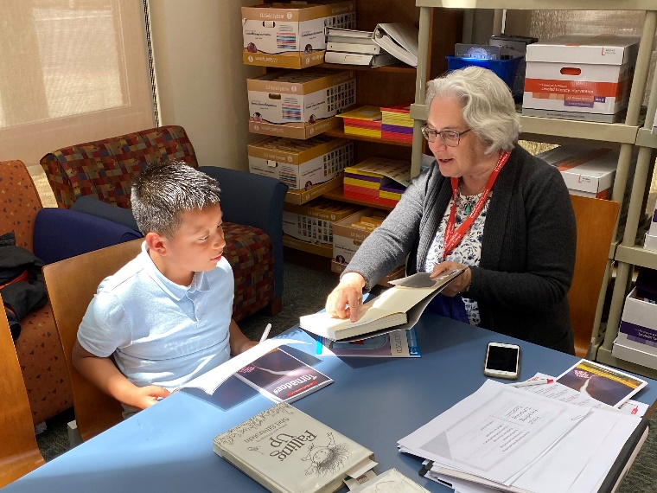

Join us!
Would you like to help young readers to achieve grade level skills? Join Experience Corps of Greater New Haven and tutor 1st, 2nd, and 3rd grade students in nearby schools and after-school programs. If you are age 50+, enjoy both reading and helping young children, join us. We provide the training and support you need. Volunteer 2 or more hours a week and commit to the school schedule from October through May.
To learn more, call Cherie Strucaly @ 203-752-3059,
x2907 or email Cherie @ cstrucaly@aoascc.org



